

**WEB TECHNOLOGY**

**LAB-DA-3**

**NAME:KATHIRAVAN.N**

**REG.NO:19MIS0097**

**1.Pick 5 corporations and hunt down their current stock prices.**

1. Place them in a neatly arranged table with their name, symbol, last price, 52wk high, 52wk low and PE ratio.
2. The end result should look like the following. Notice that the first column is aligned left and the rest are centered.
3. Now alter the last table using shaded rows and no border.

**HTML CODE:**

<html>

<head>

<title>Kathir</title>

</head>

<body>

<table cellspacing="1" cellpadding="2" border="2" align="center">

<tr>

<td align="center" colspan="6" bgcolor=""><font

size="3"><i><b>My tech stock picks</b></i></font></td>

</tr>

<tr>

<td><font size="2"><b>NAME</b></font></td>

<td align="center"><font size="2"><b>SYMBOL</b></font></td>

<td align="center"><font size="2"><b>CURRENT</b></font></td>

<td align="center"><font size="2"><b>52WK HI</b></font></td>

<td align="center"><font size="2"><b>52WK LO</b></font></td>

<td align="center"><font size="2"><b>P/E RATIO</b></font></td>

</tr>

<tr>

<td>Microsoft</td>

<td align="center">MSFT</td>

<td align="center">86-3/8</td>

<td align="center">119-15/16</td>

<td align="center">75-1/2</td>

<td align="center">56.09</td>

</tr>

<tr><td>Cisco Systems</td>

<td align="center">CSCO</td>

<td align="center">72-1/8</td>

<td align="center">82</td>

<td align="center">24-13/16</td>

<td align="center">400.69</td>

</tr>

<tr>

<td>America Online</td>

<td align="center">AOL</td>

<td align="center">63</td>

<td align="center">95-13/16</td>

<td align="center">38-15/32</td>

<td align="center">350.00</td>

</tr>

<tr>

<td>Qwest Communications</td>

<td align="center">Q</td>

<td align="center">44-7/16</td>

<td align="center">66</td>

<td align="center">25-3/4</td>

<td align="center">74.06</td>

</tr>

<tr>

<td>Dell Computers</td>

<td align="center">DELL</td>

<td align="center">53-59/64</td>

<td align="center">59-11/16</td>

<td align="center">31-3/8</td>

<td align="center">86.97</td>

</tr>

</table>

</body>

</html>

**INPUT:**

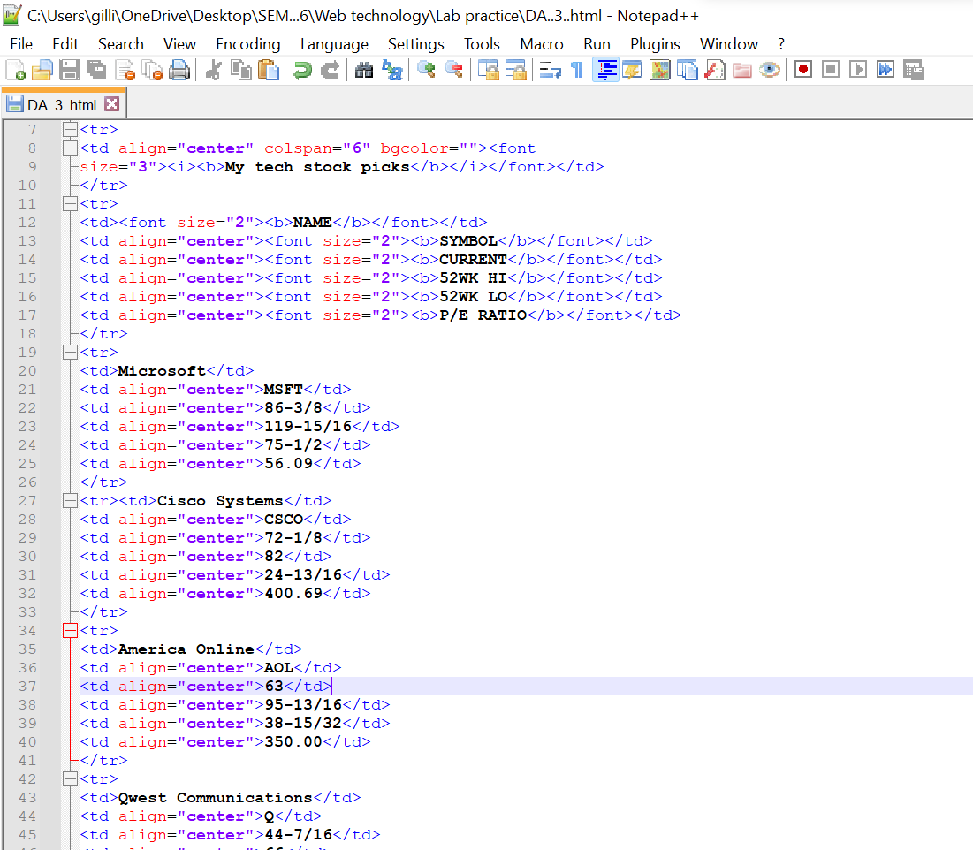

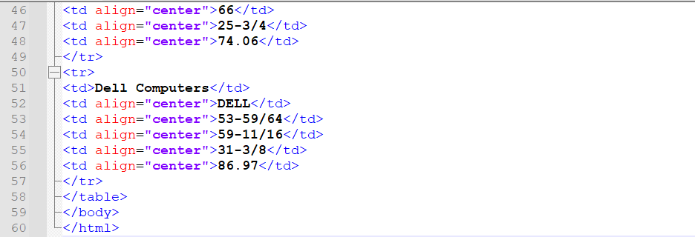

**OUTPUT:**

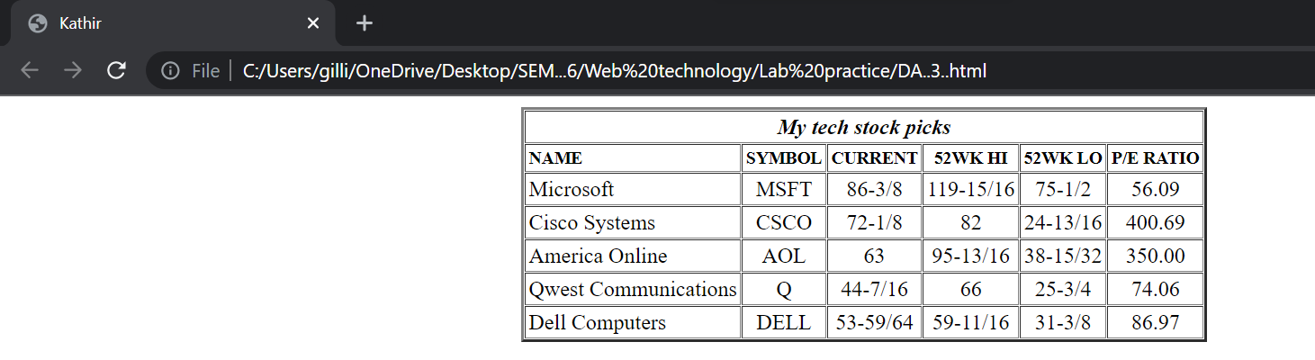

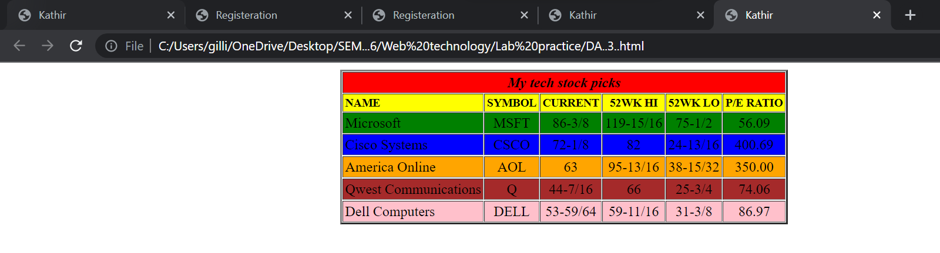

**2. Create a web page containing three divisions.**

1. The first division displays a digital clock on the rightmost end.
2. The width of the first division is 100%.The second division and third division lay side by side.
3. The second division has an image slider and third division has a color picker and two list box having font-family and size and a button. When a button is clicked the background color, font and font size should change for a whole page. Use JavaScript to implement the above.

**HTML CODE:**

<html>

<head>

<title>Kathir</title>

<script>

function displaytime() {

x=getHour();

y=getMin();

z=getSec();

document.getElementById("id1").value=x+" H";

document.getElementById("id2").value=y+" M";

document.getElementById("id3").value=z+" S";

setTimeout(displaytime,1000);

}

function getHour() {

var obj=new Date();

h=obj.getHours();

return h;

}

function getMin() {

var obj=new Date();

h=obj.getMinutes();

return h;

}

function getSec() {

var obj=new Date();

h=obj.getSeconds();

return h;

}

var slideIndex=0;

imageSlider();

function imageSlider() {

var i;

var slide=document.getElementsByClassName("fade");

for(i=0;i<slide.length;i++)

{

slide[i].style.display="none";

}

slideIndex++;

if(slideIndex>slide.length)

{

slideIndex=1;

}

slide[slideIndex-1].style.display = "block";

setTimeout(imageSlider, 2000);

}

function colorChange() {

var x=document.getElementById("mySelect").value;

document.getElementById("color").style.backgroundColor = x;

var y=document.getElementById("myfont").value;

document.getElementById("color").style.fontFamily=y;

var z=document.getElementById("mySize").value;

document.getElementById("color").style.fontSize=z;

}

</script>

<style>

* {box-sizing:border-box}

body {font-family: Verdana,sans-serif;}

.fade {display:none;

border: 5px solid black;

height: 360px;

width: 610px;

}

.image {

max-width: 1000px;

position: absolute;

top: 208px;

background-image: url("full.jpg");

padding: 20px;

height: 400px;

width: 650px;

}

#digitalclock

{

background-color: rgba(0,0,0,0.5);

float: right;

position: absolute;

top:70px;

left: 1000px;

padding: 10px;

border-radius: 10px;

}

#digital{

background-image;

background-size: contain;

position: relative;

width: 100%;

padding: 100px;

}

#digitalclock input[type=text]{

height: 50px;

width: 50px;

border-radius: 5px;

text-align: center;

color: crimson;

background-color: rgba(224, 210, 222, 1);

font-style: italic;

font-size: larger;

-webkit-filter:;

}

#color

{

position: absolute;

top: 208px;

left: 658px;

height: 400px;

width: 700px;

padding: 100px;

}

#new{

position: fixed;

background-color: #bbbbbb;

top: 450px;

left: 850px;

}

#newtext{

background-color: lightgreen;

}

</style>

</head>

<body onload=imageSlider();displaytime();>

<div id="digital">

<div id="digitalclock">

<input id="id1"type="text"><input id="id2" type="text"><input id="id3"

type="text">

</div>

</div>

<div class="image" >

<div class="fade">

<img name="" src="C:\Users\gilli\OneDrive\Desktop\SEM...6\Web technology\Lab practice" style="height:350px;width: 600px;">

</div>

<div class="fade">

<img name="imgm" src="sunflower.jpg" style="height: 350px; width: 600px;">

</div>

</div>

<div id="color" style="background-color: darkorange; ">

<div id="newtext">

<p style="border: 3px solid black;" id="text">

A flower, sometimes known as a bloom or blossom, is the reproductive

structure found in flowering plants (plants of the division Magnoliophyta, also

called angiosperms). The biological function of a flower is to facilitate

reproduction, usually by providing a mechanism for the union of sperm with

eggs.

</p>

</div>

<form>

<div id="new">

<option value="green" >green</option>

Select Color:

<select id="mySelect">

<option value="blue" >Blue</option>

<option value="green" >Green</option>

<option value="black">Black</option>

<option value="brown">brown</option>

</select>

<br>

Select Font:

<select id="myfont">

<option value="Arial" style="font-family: Arial">Arial</option>

<option value="'Baskerville Old Face'" style="font-family: 'Baskerville Old

Face'">Baskerville Old Face</option>

<option value="'Berlin Sans FB Demi'" style="font-family: 'Berlin Sans FB

Demi'">Berlin Sans FB Demi</option>

<option value="Century" style="font-family: Century">Century</option>

<option value="'Javanese Text'" style="font-family: 'Javanese Text'">Javanese

Text</option>

</select>

<br>

Size:

<select id="mySize">

<option value="large" >Large</option>

<option value="larger" >Larger</option>

<option value="medium" >Medium</option>

<option value="small">Small</option>

<option value="smaller">Smaller</option>

</select>

<br>

<input type="button" value="click" name="click" onclick="colorChange()">

</div>

</form>

</div>

</body>

</html>

**INPUT:**

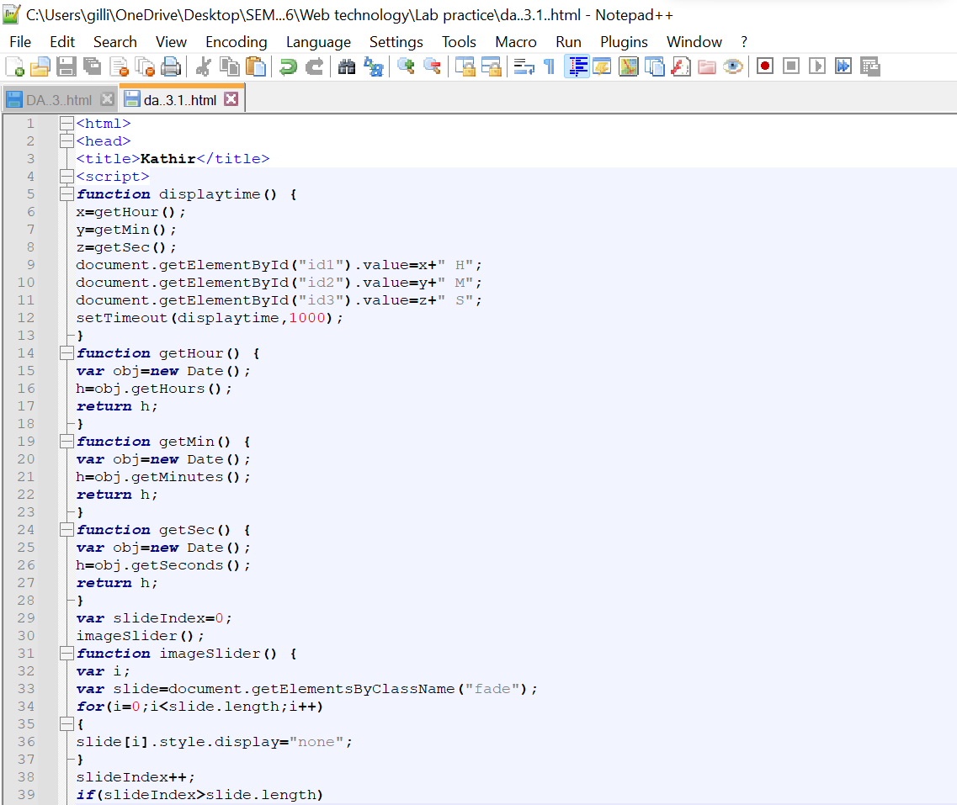

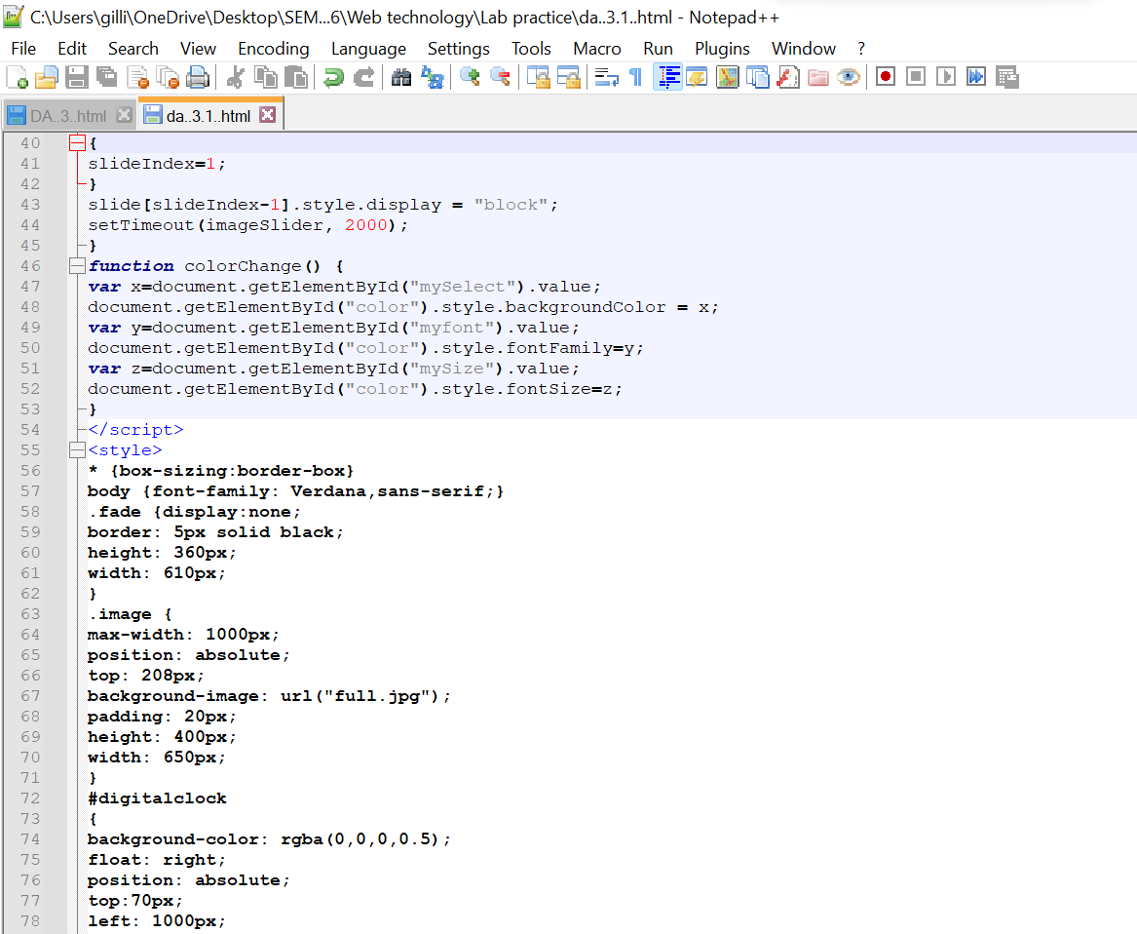

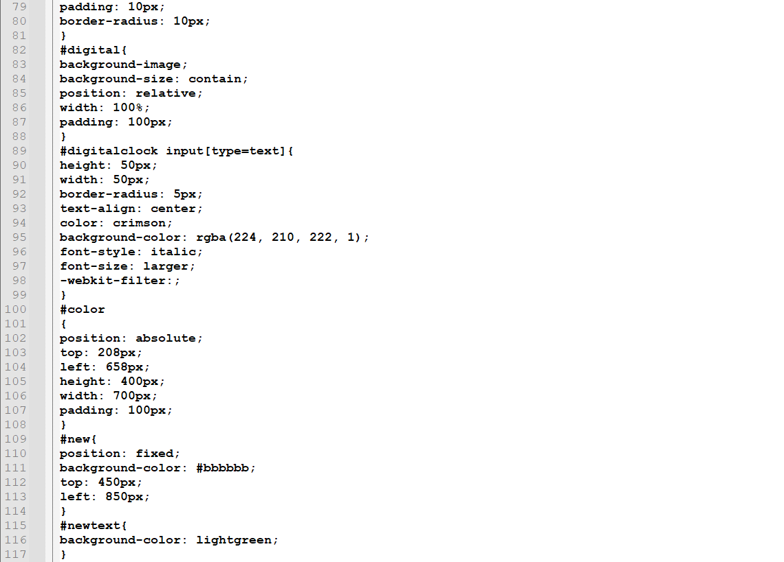

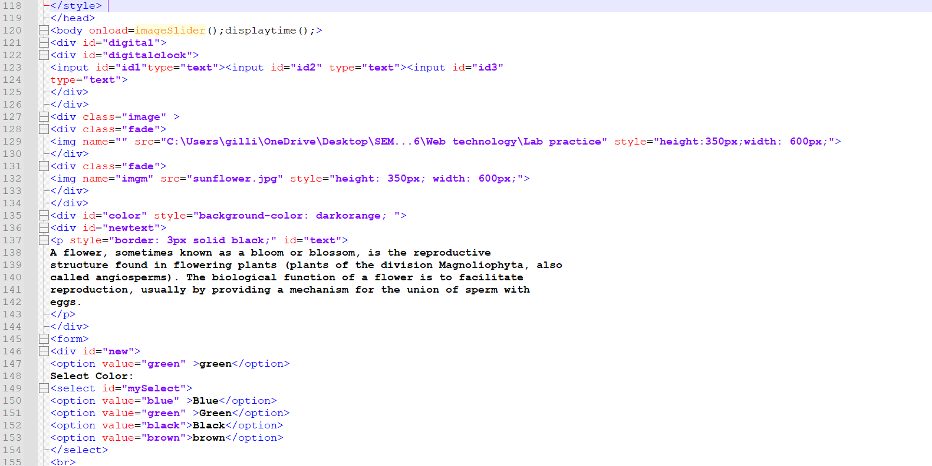

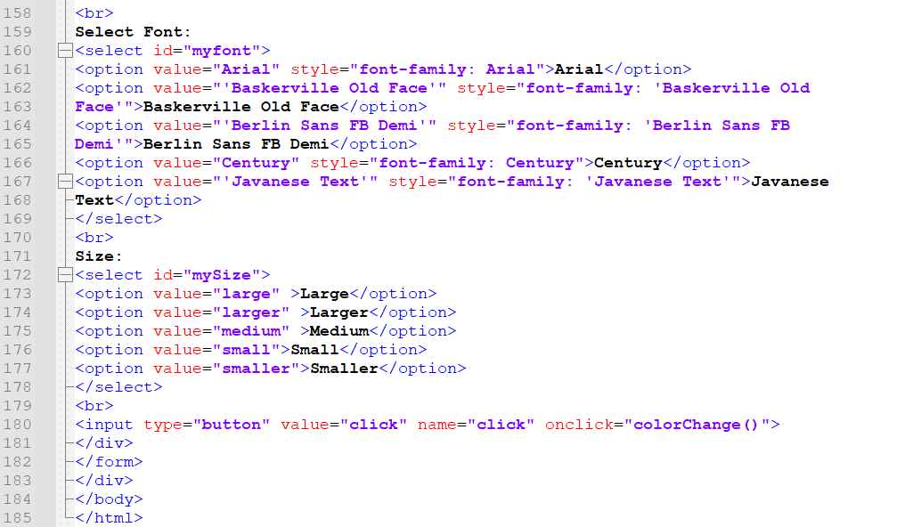

**OUTPUT:**

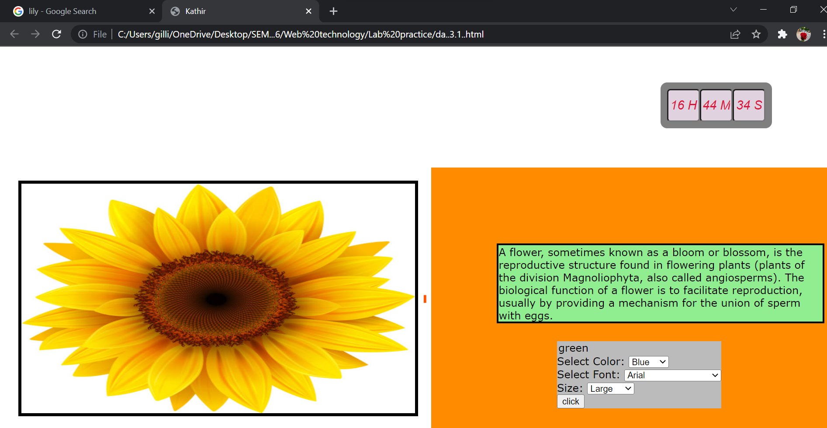

3. Design the following HTML form using HTML and javascript

1. Utilize CSS shorthand background properties to provide a color and image.
2. Utilize field set tags.
3. Check no fields are null.

**HTML CODE:**

<html>

<head>

<title>Kathir</title>

</head>

<script> function validate()

{

var n=document.getElementById("name").innerHTML; var

t=document.getElementById("toppings").innerHTML; var

s=document.getElementById("sauce").checked; var

b=document.getElementById("base").checked; var

i=document.getElementById("delivery instructions").innerHTML;

if(n == 0){ alert("Name field is Empty");} if(t == 0){

alert("select the toppings");} if (s == 0){

alert("select the sauce");}

if (b == 0){ alert("select the type of base required");}

if (i == 0){ alert("text should be filled ");

}

}

</script>

<title> pizza shop 2.0 </title>

<style>

body{

background:red

url("https://sp.yimg.com/ib/th?id=OP.PimU5R8avWhCJA474C474&o=5&pid

=21.1&bw=0&bc=FFFFFF&w=174&h=174")no-repeat fixed;

background-size:cover;

</style>

</head>

<body>

<form name="pizza" onsubmit=" validate();">

<table align="center" border="1" width="25%" height="25%">

<tr>

<th colspan="2">PIZZA SHOP 2.0 </th>

</tr>

<tr>

<td align="left" ; >Name</td>

<td><input type="text" name="name" id="name"></td>

</tr>

<tr>

<td align ="left">Pizza Topping</td>

<td><input type="radio" name="supreme" id ="toppings">supreme</br>

<input type="radio" name="vegetarian" id="toppings">vegitarian</br>

<input type="radio" name="hawaaian" id="toppings">hawaiaain</br></td>

</tr>

<tr>

<td align="left"> Pizza sauce</td>

<td >

<select name ="dropdown">

<option value="tomato" selected id ="sauce">tomato</option>

<option value="carrot" selected id ="sauce">carrot</option>

</select>

</td>

</tr>

<tr>

<td align="left" > Optional extras</td>

<td><input type="checkbox" name="extra cheese" id="base">extra cheese

<input type="checkbox" name="gluten Free Baes" id ="base">gluten free base

</td>

</tr>

<tr>

<td colspan="2" >Delivery Instructions: <br/><textarea name="Delivery

Instructions" id="delivery instructions">

</textarea>

</td>

</tr>

<tr>

<td colspan="2">

<button> Send my order</button>

</td>

</tr>

</table>

</form>

</body>

</html>

**INPUT:**

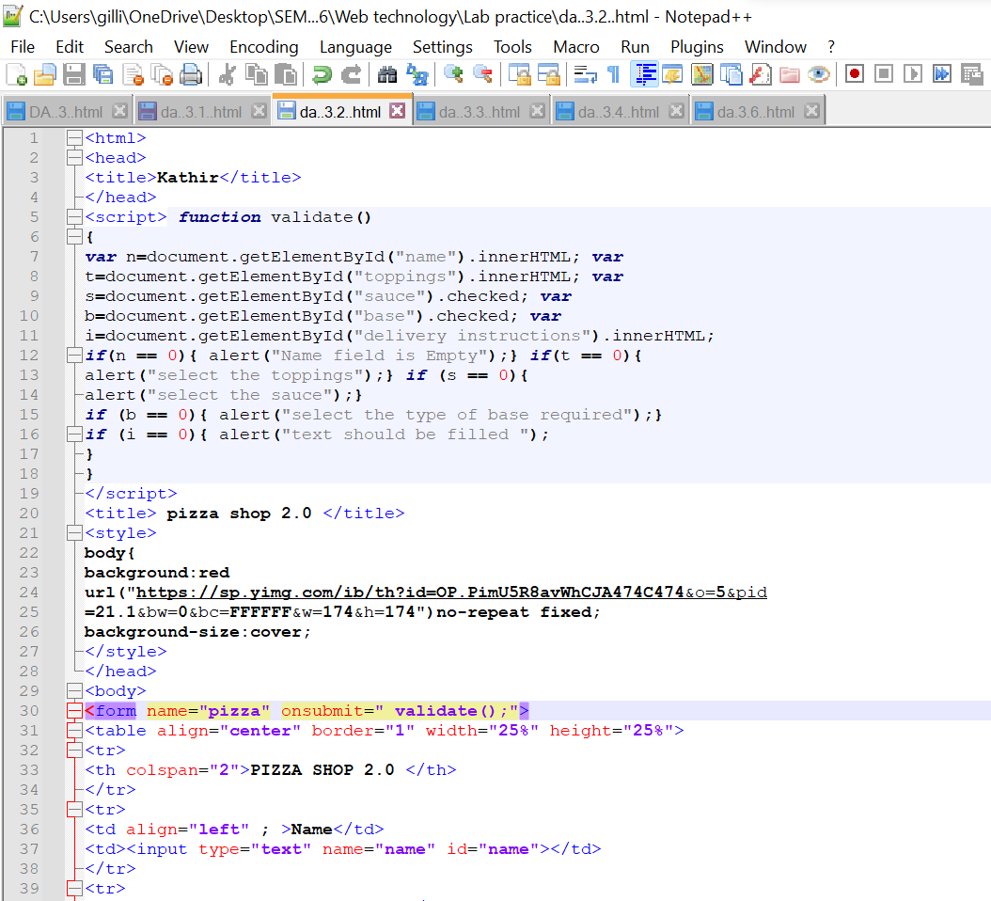

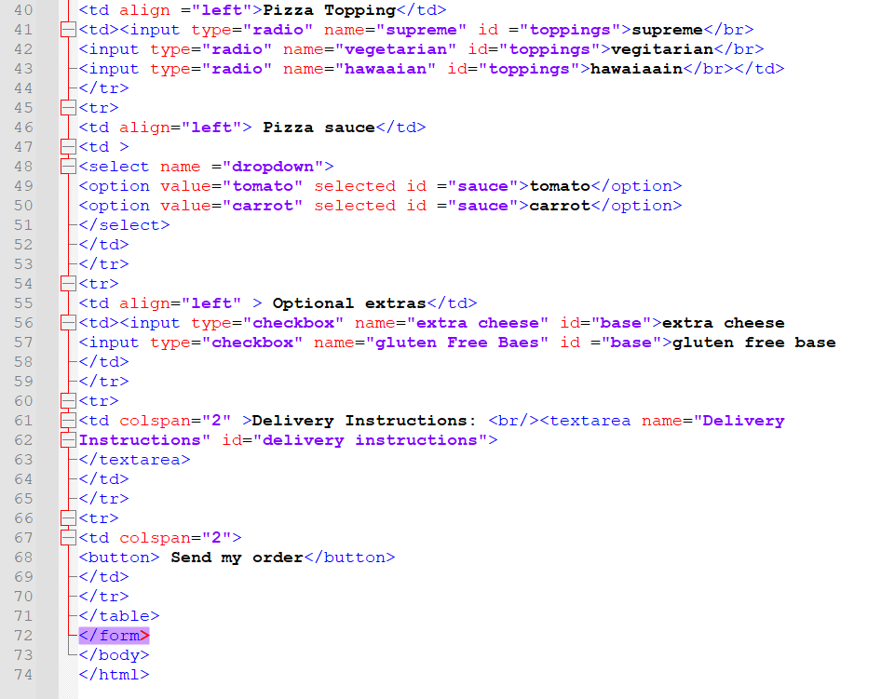

**OUTPUT:**

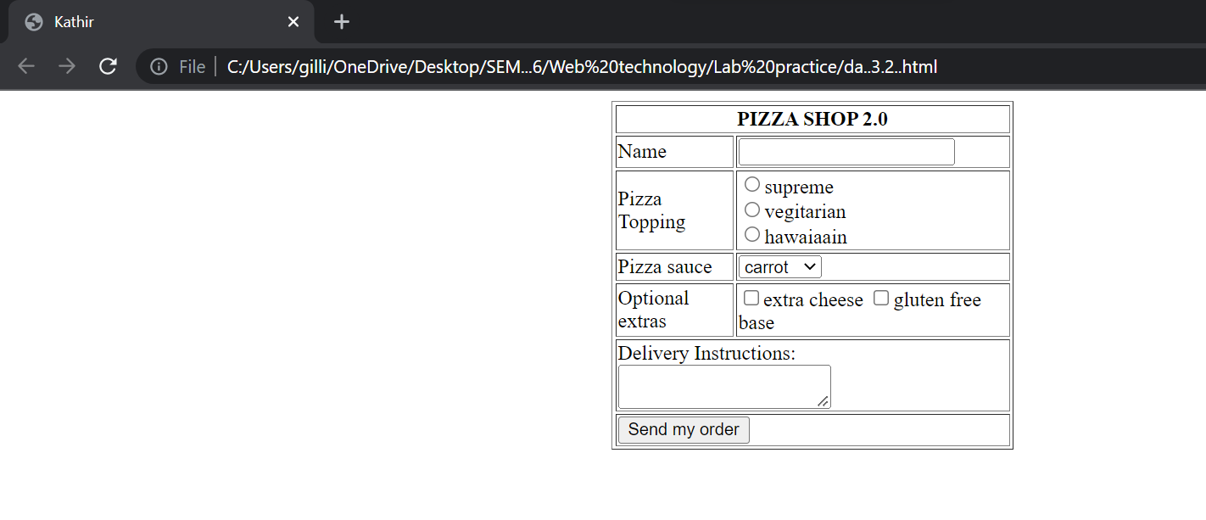

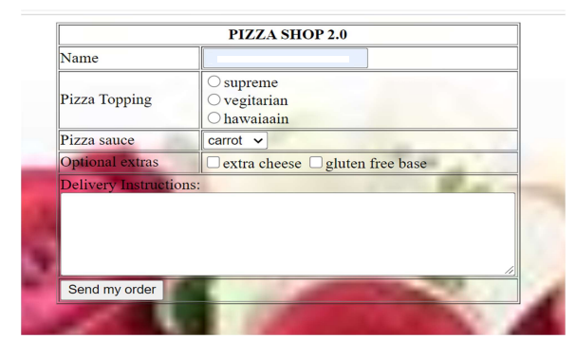

4.Design a student registration form which takes student name, register number, DOB, program, email id, temporary address, permanent address, phone number.

i) Validate the following using JavaScript:

a. Mobile number should be exactly 10 digits.

b. Register number should have alphabets and numbers only

c. Name should not exceed 30 characters and can be only alphabets.

ii) Email validation

iii) Provide a checkbox saying “Permanent address is same as temporary address”. If checked, the value of permanent address should be added automatically from temp address. And should be in disabled mode.

**HTML CODE:**

<html>

<head>

<title>Registeration</title>

<script type="text/javascript">

function validate()

{

name(document.getElementById("name").value);

reg(document.getElementById("regno").value);

mail(document.getElementById("email").value);

num(document.getElementById("phoneno").value);

}

function name(name)

{

nl=name.length;

flag=1;

for(i=0;i<nl;i++){

c=name.charAt(i);

if(!((c>='A' && c<='Z') || (c>='a' && c<='z') || c==' '))

flag=0;

}

if(flag==0)

alert("Name should contain alphabets");

}

function reg(regno)

{

flag=1;

for(i=0;i<regno.length;i++){

c=regno.charAt(i);

if(!((c>='A' && c<='Z') || (c>='a' && c<='z') || (c>='0' && c<='9')))

flag=0;

}

if(flag==0)

alert("Register number should be in alphabets and number");

}

function mail(email)

{

atp=email.indexOf("@");

dotp=email.lastIndexOf(".");

if (atp<1 || dotp<atp+2 || dotp+2>=email.length)

alert("Enter a valid E-mail ID");

}

function num(phoneno)

{

if(phno.length<10)

alert("Enter a valid phoneno");

}

function disable()

{

if(document.getElementById("check").checked)

{

document.getElementById("permadd").value=document.getElementById("te

mpadd").value;

document.getElementById("permadd").disabled=true;

}

else

{

document.getElementById("permadd").disabled=false;

document.getElementById("permadd").value="";

}

}

</script>

</head>

<body>

<center>

<form>

<table border="1" height="50" cellpadding="2">

<tr>

<th colspan="2"> STUDENT REGISTRATION FORM </th>

</tr>

<tr>

<td>Student Name:</td><td><input name="name" id="name" type="text"

maxlength="30"></td>

</tr>

<tr>

<td>Register Number:</td><td><input id="regno" type="text"></td>

</tr>

<tr>

<td>Date of Birth:</td><td><input id="dob" type="text"></td>

</tr>

<tr>

<td>Program:</td><td><input id="prog" type="text"></td>

</tr>

<tr>

<td>E-Mail ID:</td><td><input id="email" type="text"></td>

</tr>

<tr>

<td colspan="2">Temporary Address:</br><textarea id="tempadd"

></textarea></td>

</tr>

<tr>

<td colspan="2">Permanent Address:</br><textarea id="permadd"

></textarea></td>

</tr>

<tr>

<td colspan="2"><input id="check" type="checkbox"

onclick="disable();">Same as temporary address</td>

</tr>

<td>Phone Number:</td><td><input id="phoneno" type="text"

maxlength="10"></td>

</tr>

<tr><td colspan="2"><input type="submit" onclick="validate();"></td></tr>

</table>

</form>

</center>

</body>

</html>

**INPUT:**

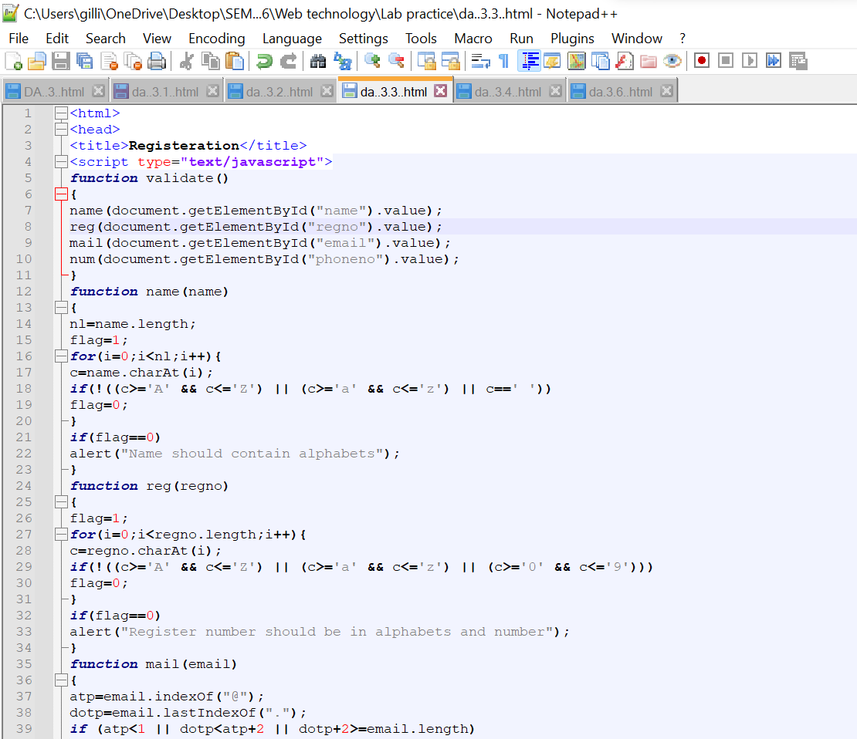

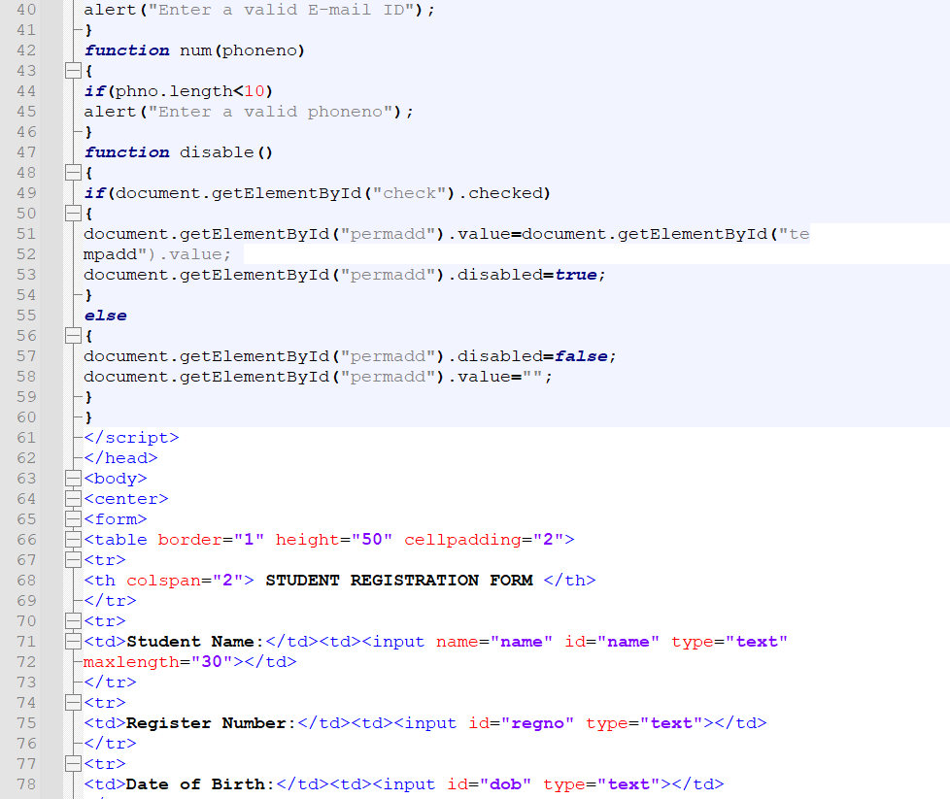



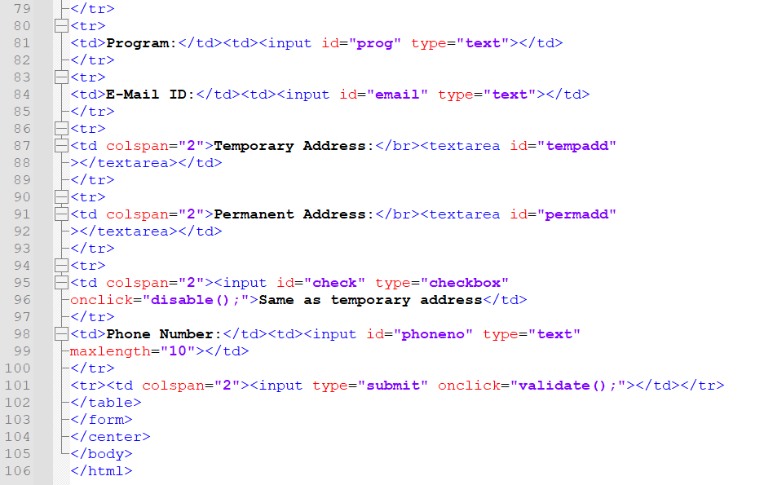

**OUTPUT:**

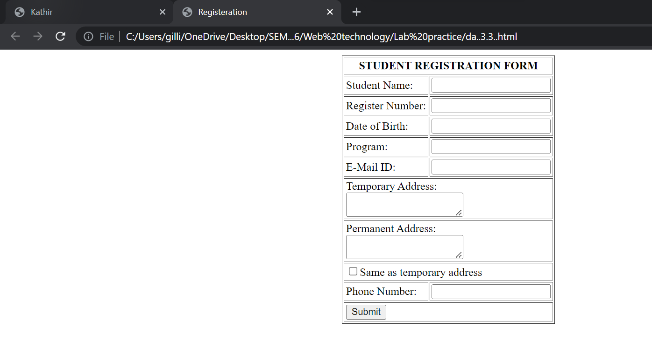

5.

i)BSNL has designed a grievance registration form in HTML with name of customer, address, telecom circle, email and grievance nature in a list box containing huge bills for limited mobile usage, roaming charges and frequent service disruption and a submit button.

ii) Write a Javascript DOM event to be enabled when the user submits the form and display the complaint details in a tabular format.

iii) If no grievance is selected, then invoke another DOM event to display “ No grievances”.

**HTML CODE:**

<html>

<head>

<title>Kathir</title>

</head>

<body>

<form>

<table align="center" border="3" >

<th colspan="7" >GRIEVANCE REGISTRATION FORM </th>

<tr>

<td>Customer Name</td>

<td><input type="text" name="text" maxlength="9"></td>

</tr>

<tr>

<Td COLSPAN="2">Customer Address</br>

<TEXTAREA ROW="5" COLS="50" NAME=" ADDRESS"></TEXTAREA>

</TD>

</TR>

<tr>

<td>Telecom circle</td>

<td><input type="text" TELCOME CIRCLE="text" maxlength="9"></td>

</td>

</tr>

<TR >

<TD>e-mail Id</TD>

<td><input type="text" e-MAIL ID ="text" maxlength="20">@gmail.com</td>

</TR>

<tr>

<td>Grievance Nature</td>

<td>

<select name="NATURE" value="default">

<option name="BILLS FOR LIMITED MOBILE USAGE">BILLS FOR LIMITED

MOBILE CHARGES</option>

<option name="ROAMING CHARGES">ROAMING CHARGES</option>

<OPTION NAME="FREQUENT SERVICE DISTIBUTION">FREQUENT SERVICE

DISTIBUTION</OPTION>

</select>

</td>

</tr>

<TR>

<td colspan="2"><INPUT TYPE="SUBMIT" NAME="COMPLETE"

VALUE="COMPLETED"/>

</TR>

</table>

</form>

</body>

</html>

**INPUT:**

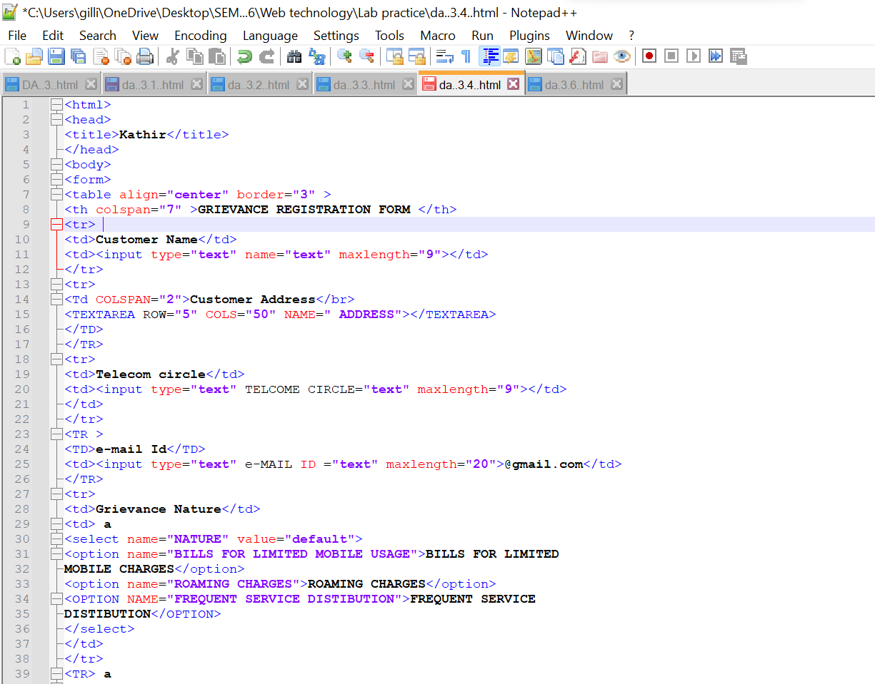

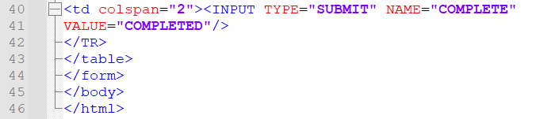

**OUTPUT:**

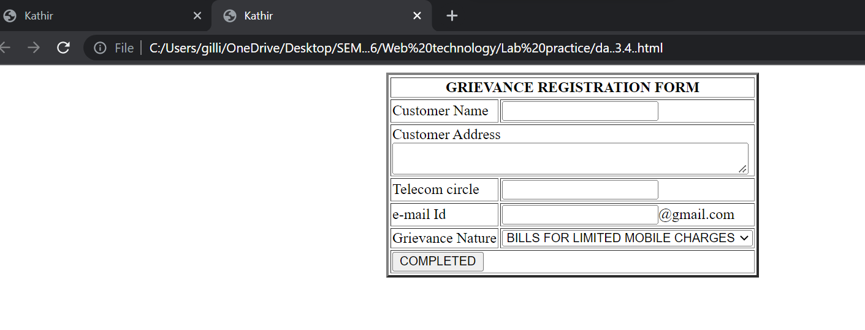

6. Develop an online Railway Reservation application.

i) It has top frame with the name “Online Railway Reservation System” in the middle, there is a logo/image in the left corner using suitable CSS styles and the left frame with the links for Ticket booking and availability checking; for each link the target should be the right frame.

ii) Create a Ticket Booking form which should have From and To in a text box, Train Names in a drop down box, Coach Number in a list box, Date in a date field, Timing in a text box, Passengers Male and female in a dropdown menu showing the count number and Submit and Reset button.

iii) Assume availability of tickets already declared in the script. Create a DOM event to display the ticket confirmation details on any HTML element when ticket is available otherwise display “tickets not available” by invoking any other DOM event.

**HTML CODE:**

main.html:

<html>

<head>

<title> railway registration</title>

</head>

<frameset rows="10%,*">

<frame src="online.html"/>

<frameset cols="10%,*"/>

<frame src="left.html" name="left"/>

<frame src="right.html"name="right"/>

</frameset>

</frameset>

</html>

right.html:

<html>

<head>

<title> right frame</title>

<style>

body{

background-image:url("http://www.tmr.qld.gov.au/-

/media/Projects/N/New-Generation-Rollingstock/rollout/trainside.jpg?la=en"); background-size:cover;

}

</style>

</head>

<body>

</body>

</html>

left.html:

<html>

<head>

<title> left frame</title>

</head>

<body>

<a href="ticketbooking.html" target="right"> Book Ticket </a><br/>

<a href="checkavailability.html" target="right"> Check Availability </a><br/>

</body>

</html>

online.html:

<html>

<div>

<image src="C:\Users\deepi\Downloads\logo.jpg" height="50" width="50"/>

<center>

<h1> ONLINE RAILWAY RESERVATION BOOKING </h1>

</div>

</html>

ticketbooking.html:

<html>

<head>

<title> tic booking </title>

<style> th,td { font-size:25px;

}

</style> <script> function fun1(){

var x=document.getElementById("from1").value; var

y=document.getElementById("to1").value; var

z=document.getElementById("passenger").value; if(z=="") {

alert("enter number of passengers"); return false;

}

if(z>0&&z<=5)

{

document.getElementById("a").innerHTML="your ticket from "+x+" to "+y+"

confirmed. ";

} else {

alert("tickets not available" );

}}

</script>

</head>

<body>

<form>

<table border="1" align="center" cellpadding="10" cellspacing="5" >

<tr>

<td>From</td>

<td><input type="text" id="from1" required /></td>

</tr>

<tr>

<td>To</td>

<td><input type="text" id="to1" required /></td>

</tr>

<tr>

<td>Train Name</td>

<td>

<Select name="dropdown" required>

<option value="sabari" >SABARI</option>

<option value="venkatadri">CHENNAI</option>

<option value="narayanadri" >BANGALORE</option></select></td>

</tr>

<tr>

<td>Couch Number</td>

<td>

<Select required>

<option value="s1" > S1 </option>

<option value="s2"> S2</option>

<option value="s3" > S3 </option></select></td>

</tr>

<tr>

<td>Date</td>

<td><input type="Date" name="Date" required /></td>

</tr>

<tr>

<td>Timing</td>

<td><input type="text" name="Timming" required /></td>

</tr>

<tr>

<td>Gender</td>

<td>

<Select name="dropdown" required >

<option value="male" > Male </option>

<option value="female"> Female </option>

</select></td>

</tr>

<tr>

<td>No of passenger</td>

<td><input type="text" id="passenger" required /></td>

</tr>

<tr align="center">

<td colspan="2">

<input type="submit" name="Submit" value="submit"/>

<input type="reset" name="Reset" value="reset"/>

</td>

</tr>

</table>

</form>

<button onclick="fun1()" style="margin-left:650px"

>Confirm</button><br/><br/>

<p id="a"></p>

</body>

</html>

checkavailability.html:

<html>

<head>

<title>frame</title>

</head>

<body>

<img src= "C:\Users\deepi\Downloads\logo.jpg"width="50px" height="50px"

style="float:left;"/> <p>

To check the availability of train please select the train name and number of

passengers in <a

href="ticketbooking.html"> Ticket booking</a></p>

</body>

</html>

**INPUT:**

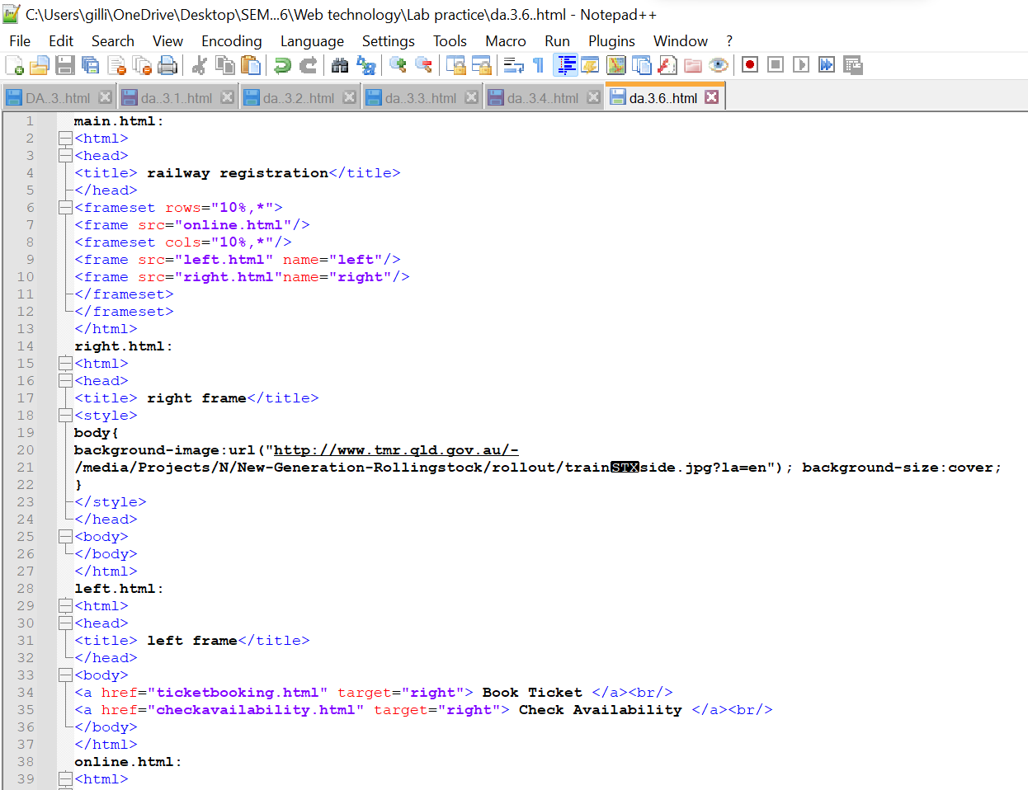

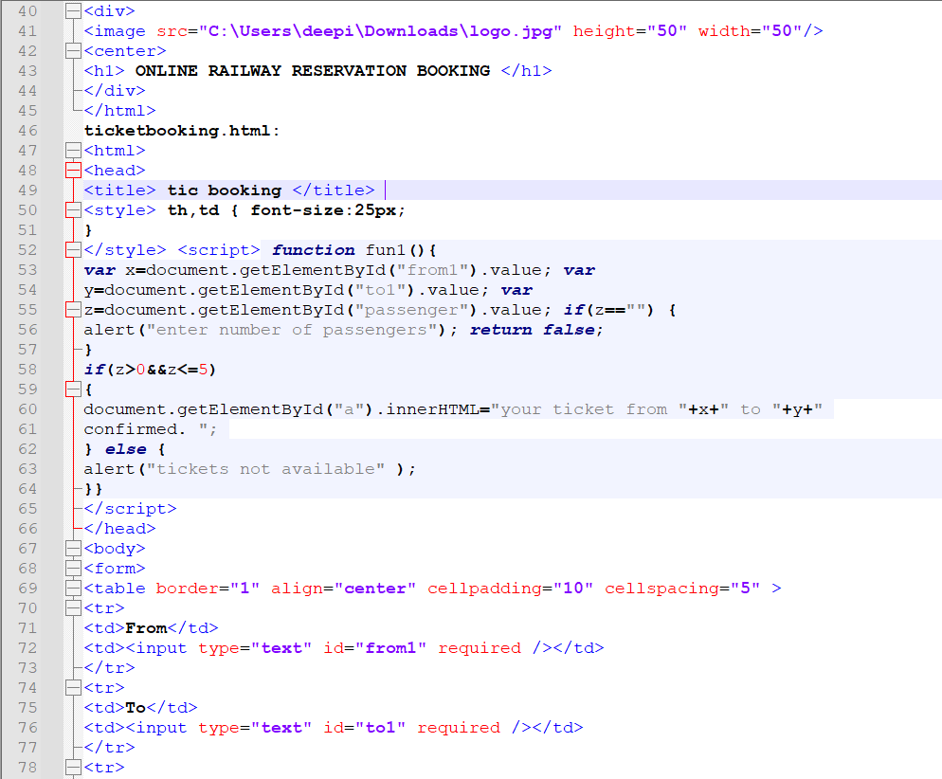

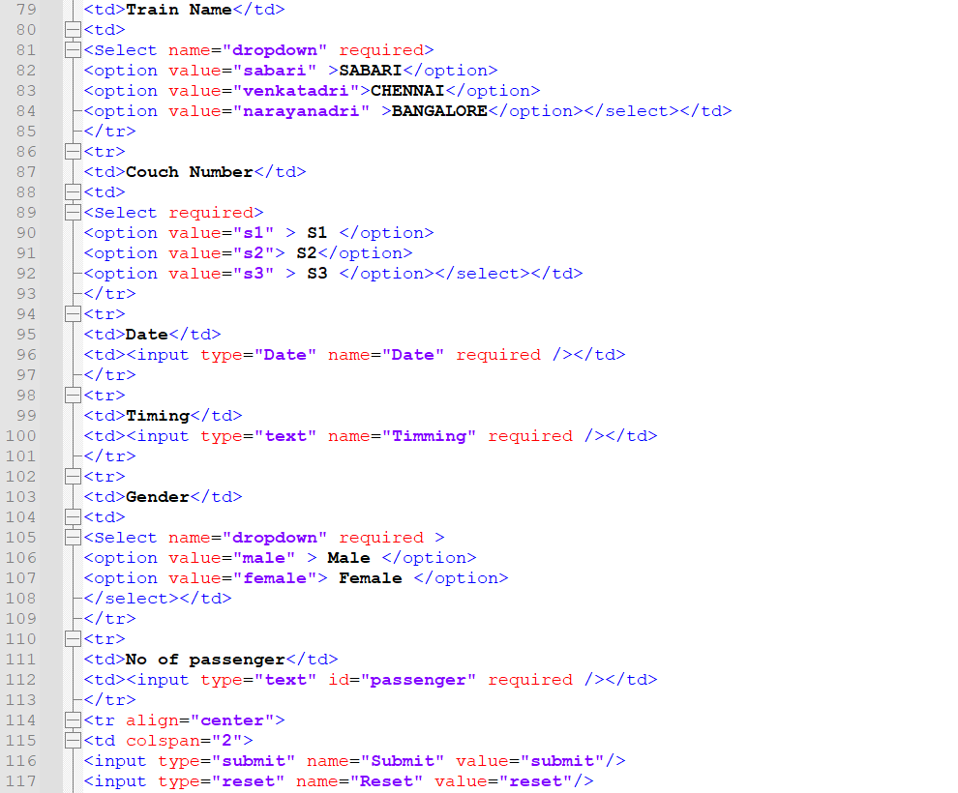

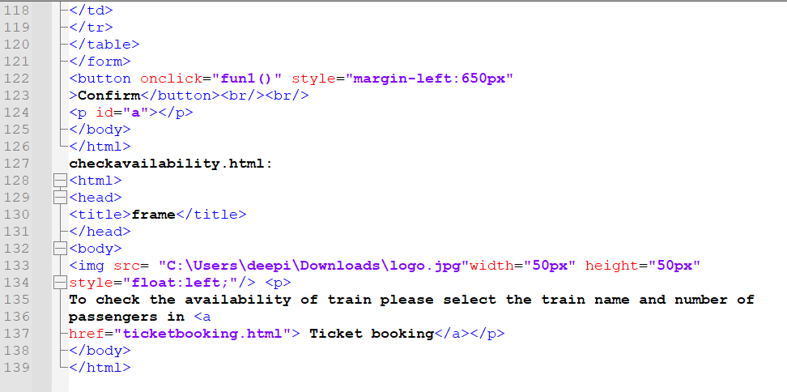

**OUTPUT:**

**MAIN PAGE:**

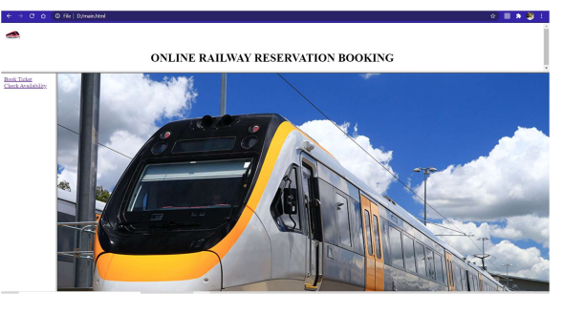

**TICKET BOOKING:**

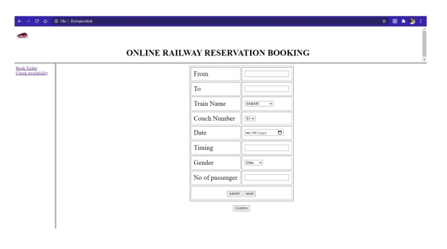

**CHECK AVAILABILITY:**

